

PROJECT TITLE

### EMPLOYEE WEBSITE MONITORING USING PACKET ANALYSIS

**Mini Project**

Submitted By

**ADITI (RA2011003010004)**

**G SHREEJA (RA201100301007)**

**MITASREE SATPATI(RA2011003010005)**

Under the Guidance of

**Mrs. P. Nityakani**

## BACHELOR OF TECHNOLOGY IN DEPARTMENT OF COMPUTER SCIENCE AND ENGINEERING

Of FACULTY OF ENGINEERING AND TECHNOLOGY



**SRM Institute of Science and Technology Kattankulathur-603 203**



### This is to certify that Computer Communication Lab Mini Project entitled

**“EMPLOYEE WEBSITE MONITORING USING PACKET ANALYSIS”**

### Submitted

**for the partial fulfilment of the requirement for Semester IV Subject of Computer Communication Lab to the SRM Institute of Science and Technology, is a bonafide work carried out during Semester IV in Academic Year 2022-2023.**

BY-

# “ADITI – RA2011003010004”

**“ G Shreeja (RA201100301007)”**

**“MITASREE SATPATI(RA2011003010005)”**





### Declaration

We declare that this written submission represents our ideas in our own words and where others’ ideas or words have been included, we have adequately cited and referenced the original sources. We also declare that I have adhered to all principles of academic honesty and integrity and have not misrepresented or fabricated or falsified any idea/data/fact/source in my submission. We understand that any violation of the above will be cause for disciplinary action by the Institute and can also evoke penal action from the sources which have thus not been properly cited or from whom proper permission has not been taken when needed.





### Table of content

|  |  |  |
| --- | --- | --- |
| **Sr. no** | **Chapter** | **Page No.** |
| **1** | Abstract | **1** |
| **2** | Introduction | **2** |
| **3** | Addressing Table | **3** |
| **4** | Network Topology Diagram | **4** |
| **5** | Output Screenshot | **7** |
| **6** | References | **9** |
| **7** | Conclusion | **9** |





**Abstract**

This project understands and demonstrates the technique which can be used to monitor the websites accessed by employees based on IP and mac- address on a LAN network by analyzing appropriate packets. Wireshark is combined with port mirroring feature on a switch to achieve the solution.

In this project we have used Cisco Packet Tracer. After implementation of all pcs and servers, the system is tested in different stages, and it was successful for its purpose.





**Introduction**

An ideal Employee monitoring system will be fully network base and easy with friendly user interface staff task management system where any banking system manage their networking system somehow Head office, Branch Office are maintained LAN, MAN, WAN, VLAN, VLSM, VPN and some branches are maintained by manageable switch.

LAN is used by Local Area Networking system for example one office and a one building. And MAN is using by the Metro Politian area Network for Example small town. In this networking system are used by all banking users can use by shared their data very easily. So that every user use to take about Network Structure & Security of Employee system instantly this way anywhere.

The need for computer networking was borne out of the need to use personal computers for sharing information within an organization in the form of messages, sharing files and databases and so forth. Whether the organization is in one building or spread over a large campus, the need for networking the computers cannot be overemphasized. As the name implies, a Local Area Network (LAN) interconnects computers in a limited geographic area. It provides high-bandwidth communication over inexpensive transmission media.

To start communication between end-user devices and to design a network, we need to select appropriate networking devices like routers, switches, and make a physical connection by connecting cables to serial and fast Ethernet ports from the component list of packet tracer. Networking devices are costly, so it is better to perform first on packet tracer to understand the concept and behavior of the network.





### Addressing Table

|  |  |  |  |  |
| --- | --- | --- | --- | --- |
| DEVICE | INTERFACE | IP ADDRESS | SUBNET MASK | GATEWAY |
| PC1 | Fa0/0 | 192.168.10.1 | 255.255.255.0 | 192.168.10.1 |
| PC2 | Fa0/0 | 192.168.10.2 | 255.255.255.0 | 192.168.10.2 |
| PC3 | Fa0/0 | 192.168.10.3 | 255.255.255.0 | 192.168.10.3 |
| PC4 | Fa0/0 | 192.168.10.4 | 255.255.255.0 | 192.168.10.4 |
| ROUTER 1 | GIGABIT 0/0 | 192.168.10.1 | 255.255.255.0 | - |
| ROUTER 2 | GIGABIT 0/1 | 192.168.11.1 | 255.255.255.0 | - |



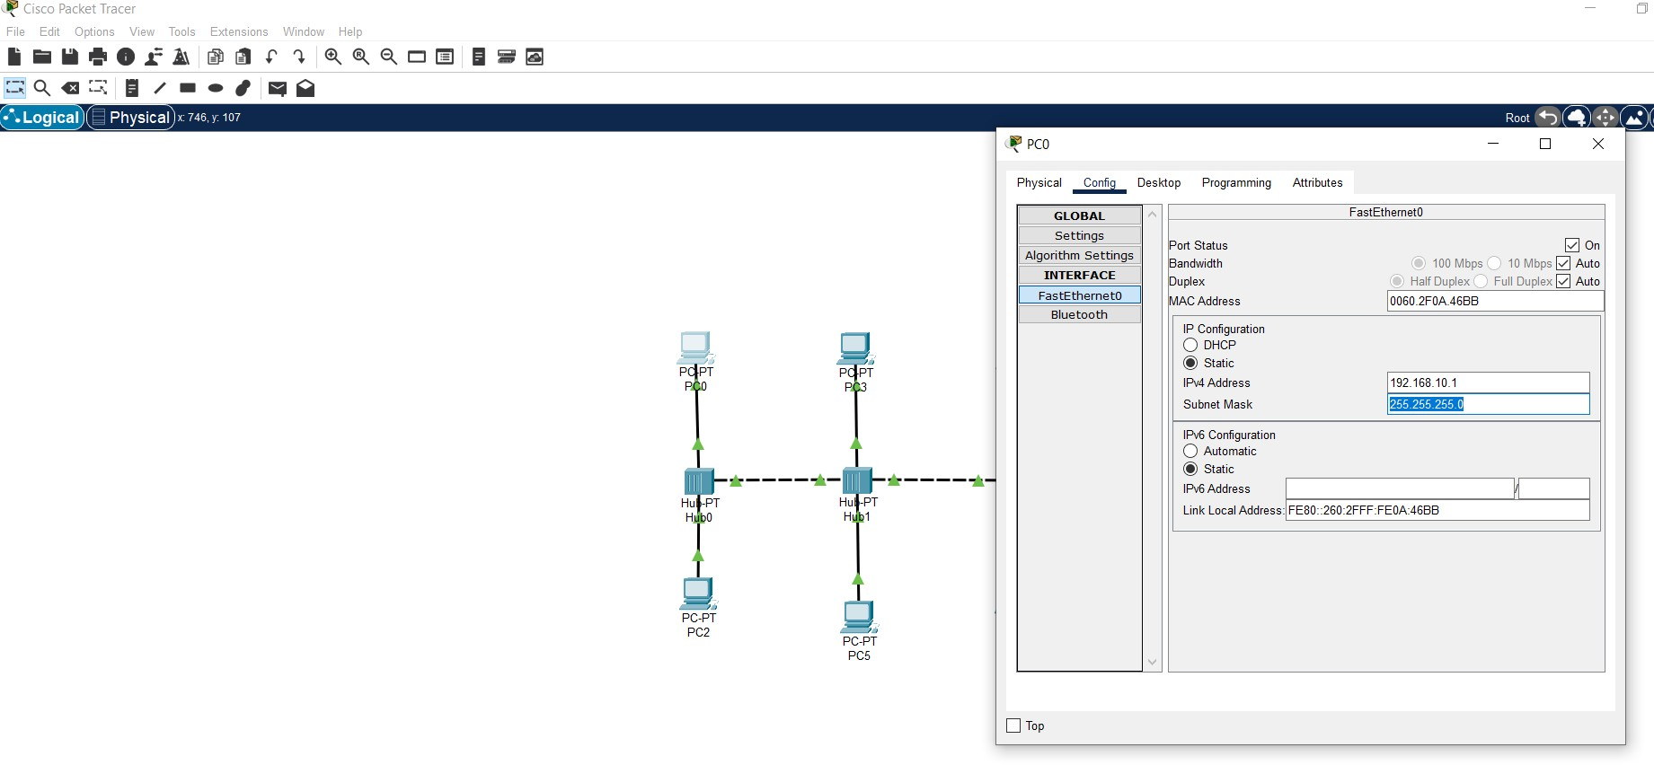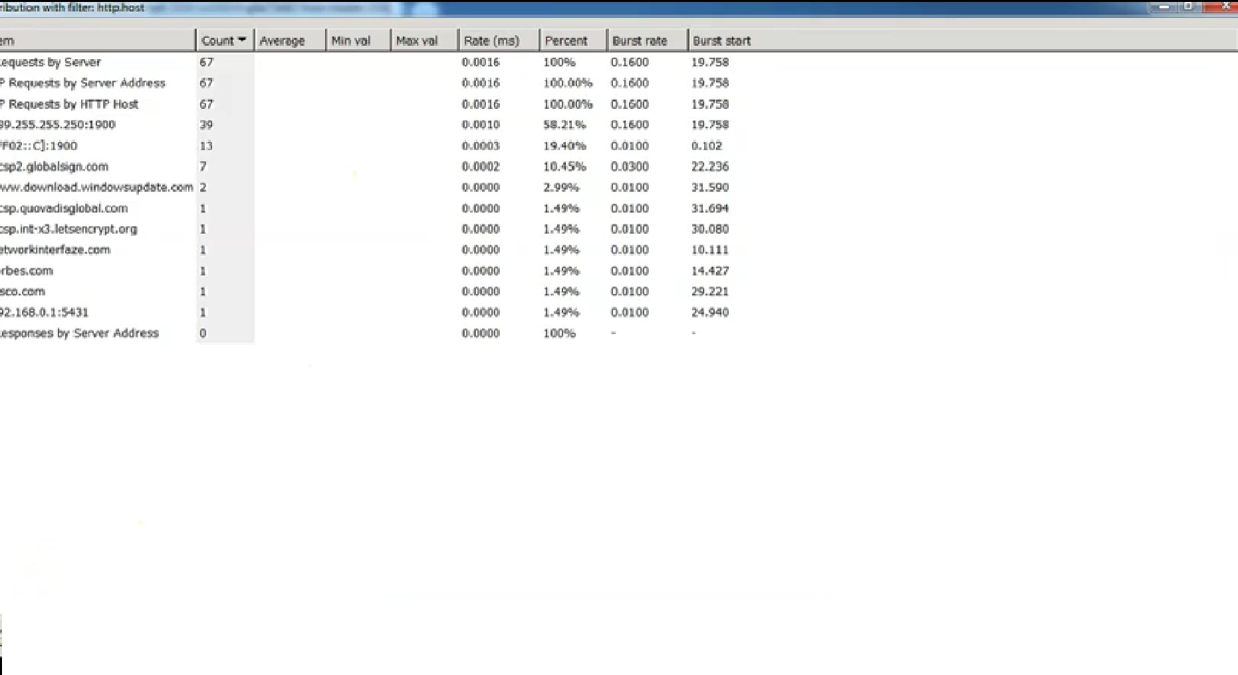

**Network Topology Diagram**

**Output Screenshot**





**References**

* https://www.youtube.com/watch?v=z88F_-vIVs0

**Conclusion**

Now a days, technological development, and automated system development is more essential and crying need for the expansion of banking services because they will need less employers by using automated system. On top of that Security is a major issue regarding banking issues. With this system network will be easier to handle and it will route the data in a shortest path in a vast distributed system. In future we will try to implement it in real life so that banks can use it and get benefited from this project. The main goals are to optimize the network resources, to give security and to provide real-time users monitoring, to avoid time- wasting. As a result of this work, the solution implemented can be changed according to current organization requirements. This is especially useful because the workstations can be easily.